**User manual**

Requirements:

Python

Web browser (even Microsoft edge will work)

Victoria State Accident DataSet

**Configure the interpreter**

Open the interpreter’s command line

Install necessary library using the commands below:

pip install pandas

pip install streamlit

**Run the application:**

The user needs to open a new command line for the interpreter after instals and type the following command. To generate this command for themselves the user can hit run using pycharm on the UI_development.py and it will give them the command below.

streamlit run C:\Users\eddie\PycharmProjects\Assignment-task-1\UI_development.py

they must use the command streamlit run. Then they need to specify the location of the file and also the files name. this will prompt them to use a application to run it. The users should use a web browser of their own choice. This will generate the page below.

**Upload the CSV file**

Must be on the accident analysis app launch page as seen below.

From here you click on browse filles button. In doing so it will prompt you to select a file within your local system to use. Make sure you select the Crash Statistics Victoria data set file. In doing so you will be greeted with the page below. This is the accident analysis apps home page.

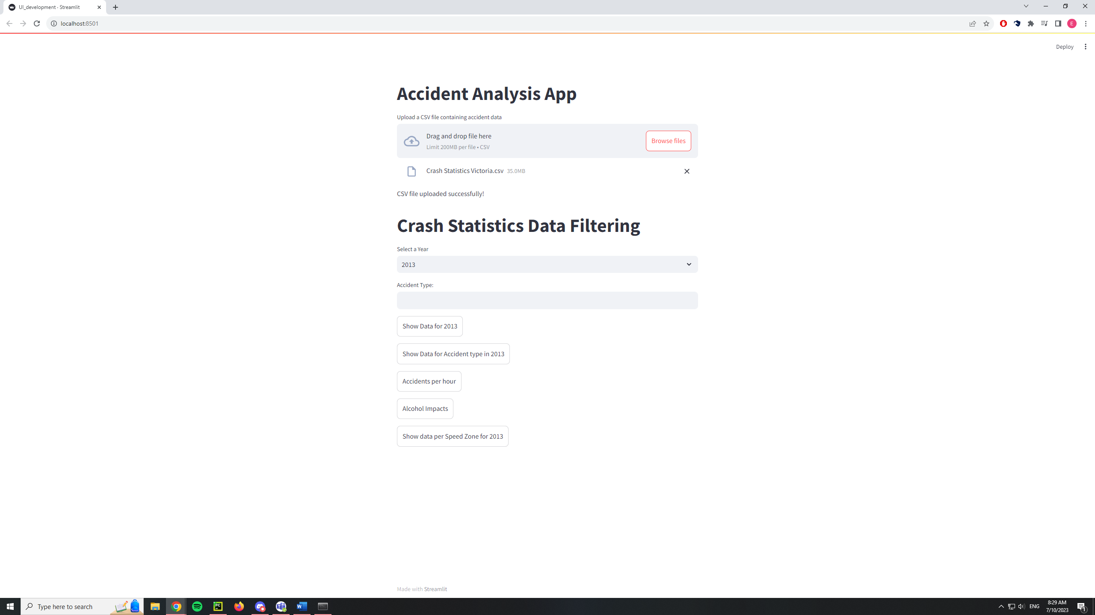

**Selecting time**

By default the selected year will be 2013. If you wish to change the year click on the section where it says select year. This will generate a drop down menu. Then click on the year you wish to change to. The drop down can be seen below.

**Show summary data for the year**

After selecting the year you can view a summary of the data. Clicking on the button labeled Show Data for 2013 will achieve this. The 2013 part of the button title will change based on the year you selected earlier. An example can be seen below.

**Search by accident type**

To search by accident type you must input a accident type into the provided text box labeled accident type. To confirm the type you wish to use make sure to press enter after typing in the type you wish to use. After this press the Show Data for Acccident type in 2013. The 2013 part of the button title will change based on the year you selected earlier.

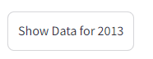

**Accidents per hour**

For a visual representation for accidents per hour press the accidents per hour button. This will generate a graph. Make sure that the year is selected first or else it will use 2013 as the default. An example of the button can be seen below.

**Alcohol impacts**

For the impacts that alcohol has press the alcohol impacts button. This will generate a table and a pie chart. Make sure that the year is selected first or else it will use 2013 as the default. An example of the button can be seen below.

**Speed zones**

For analysis of speed zones press the Show data per Speed Zone for 2013. The 2013 part of the button title will change based on the year you selected earlier. By pressing this button a graph and table will appear before you to showcase the link between speed zones and accidents. An example of the button can be seen below.

